Experiment:1
AIM : Simulation and Comparative Analysis of FDMA, TDMA and CDMA: Resource Allocation, User Capacity and MobileGeneration Context
OBJECTIVES:
By the end of the experiment, students should be able to:
1. Model how FDMA, TDMA and CDMA allocate communication resources among users.
2. Estimate and compare user capacity under stated assumptions.
3. Plot how estimated CDMA SIR changes as the number of simultaneous users increases.
4. Relate the access methods to representative mobile generations and interpret the limits of the simplified model.
PROGRAME CODE:
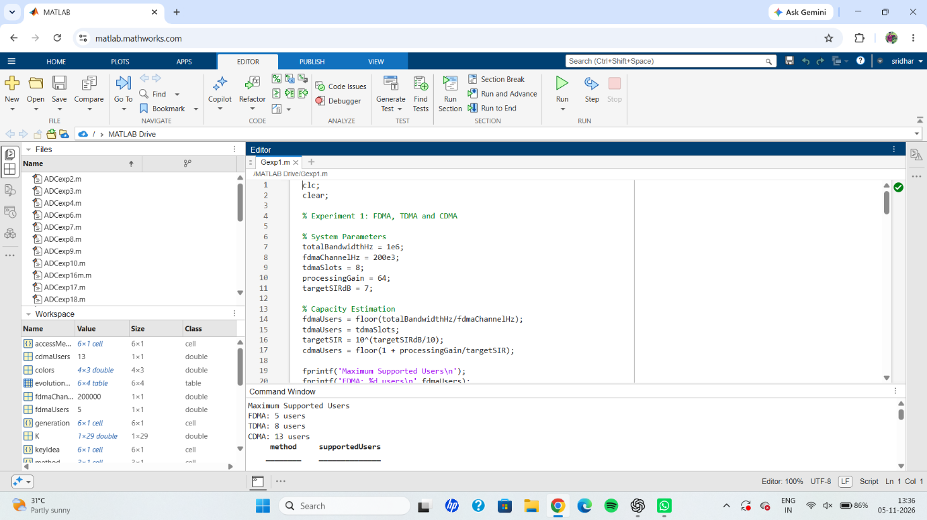
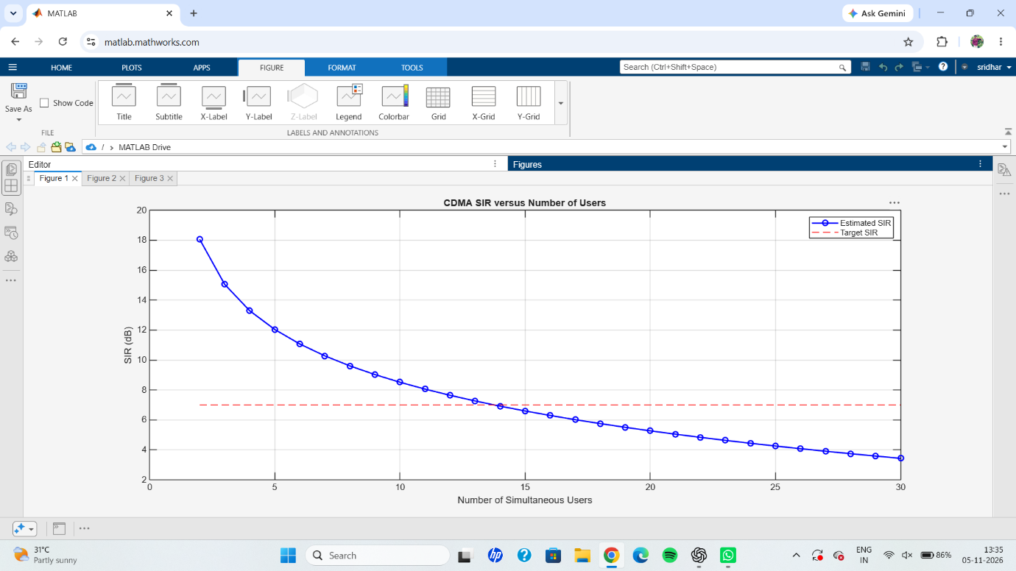
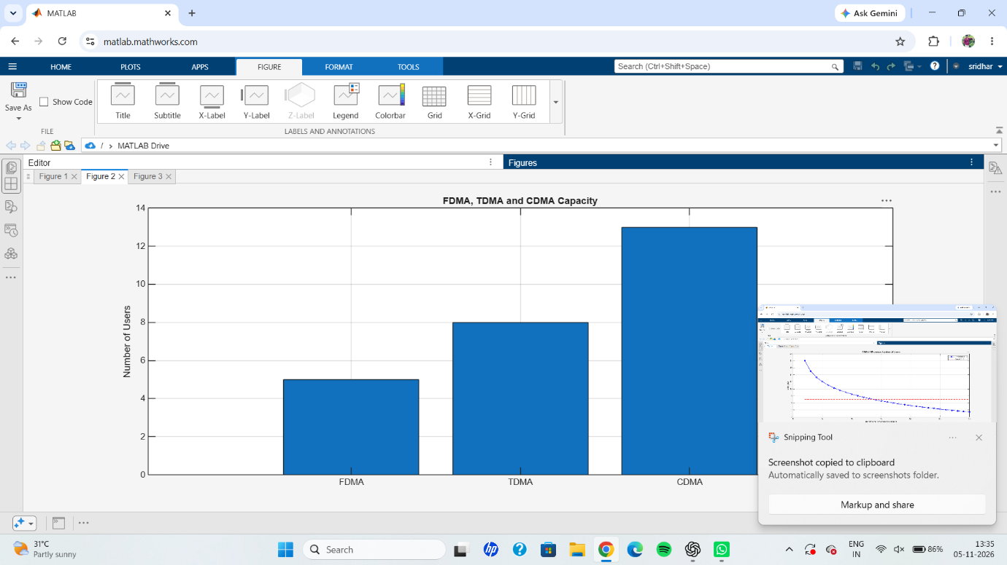
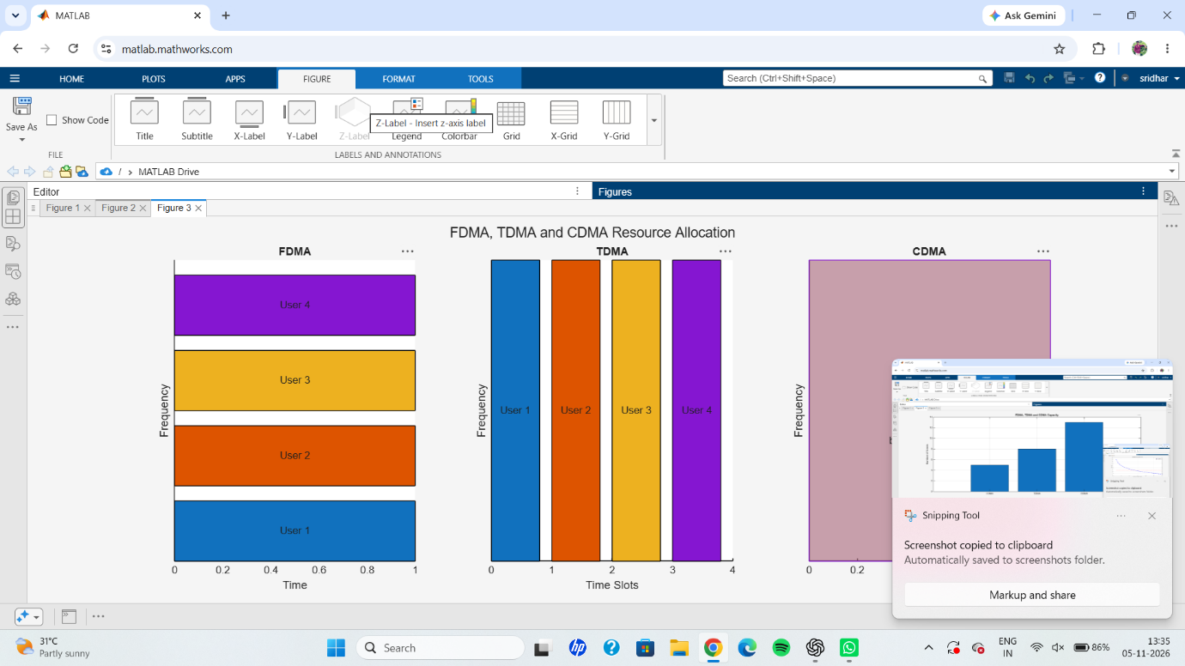
RESULT: The simulation and comparative analysis of FDMA, TDMA and CDMA were successfully performed using MATLAB. The estimated user capacities were 5 users for FDMA, 8 users for TDMA, and 13 users for CDMA. The CDMA SIR graph showed that the signal-to-interference ratio decreases as the number of simultaneous users increases. The comparison graphs and resource-allocation diagrams clearly demonstrated the differences between the three multiple-access techniques and their applications in mobile communication systems.

